Model Development

## 64 vs 32 batch size

64 batch size (1h 21m 38s):

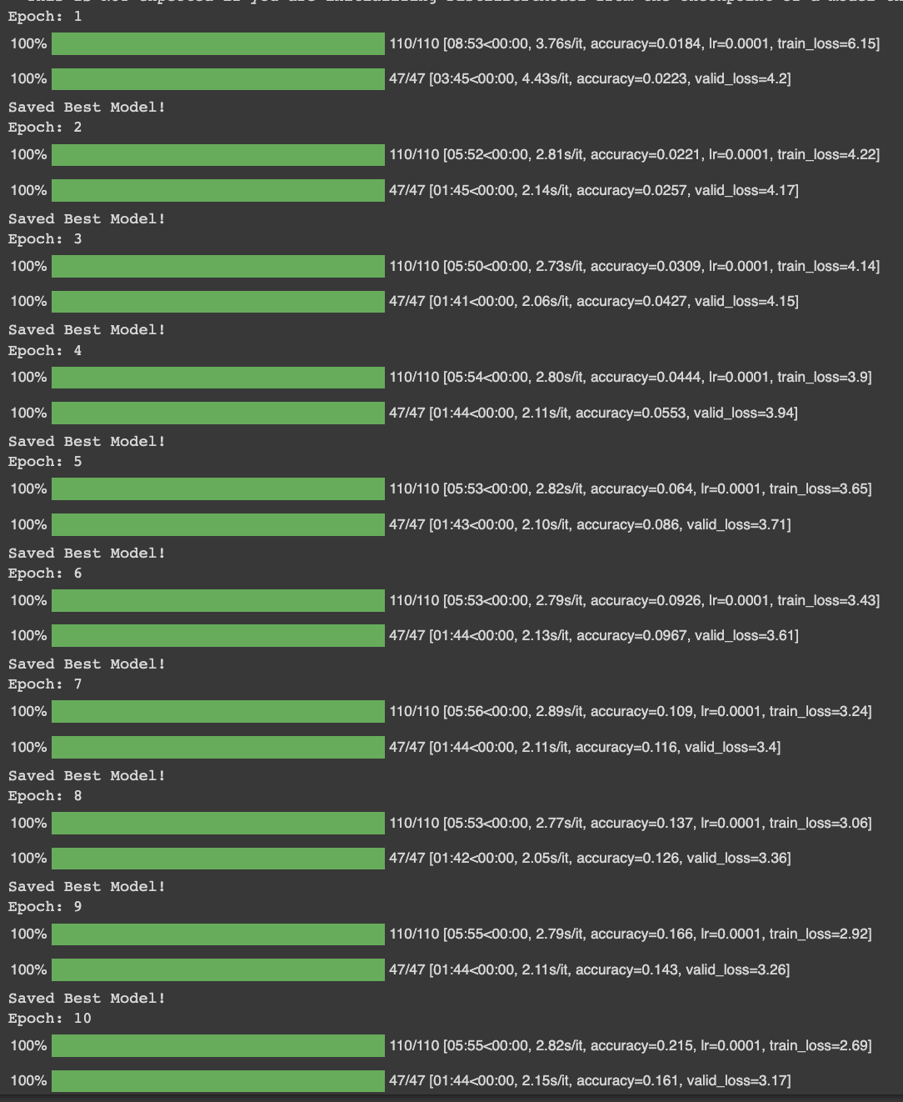

32 batch size(1h 46m 6s):

